Modify the JSON app: instead of displaying the list of verses in a sequence of toasts, store the verses in an array and display them in a ListView nicely as part of the layout for the main activity.

MainActivity.java : The 'DownloadTextTask' and 'DownloadImageTask' methods in the JSON app's 'MainActivity' are critical. The former retrieves JSON data from a web API, parses it, and populates a 'ListView', similar to how the prior app displayed contact information. The latter retrieves an image from a URL and changes a 'ImageView', similar to how contact images are shown. Both tasks run asynchronously through 'AsyncTask' to ensure a responsive user interface, with error handling and logging incorporated for smooth operation and debugging.

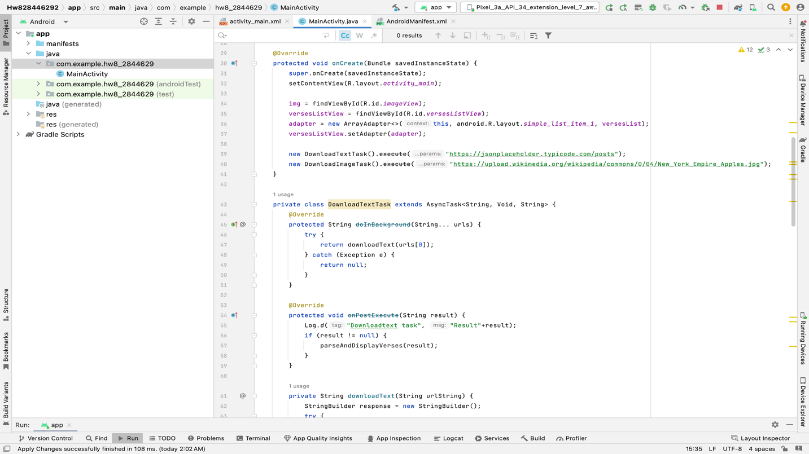

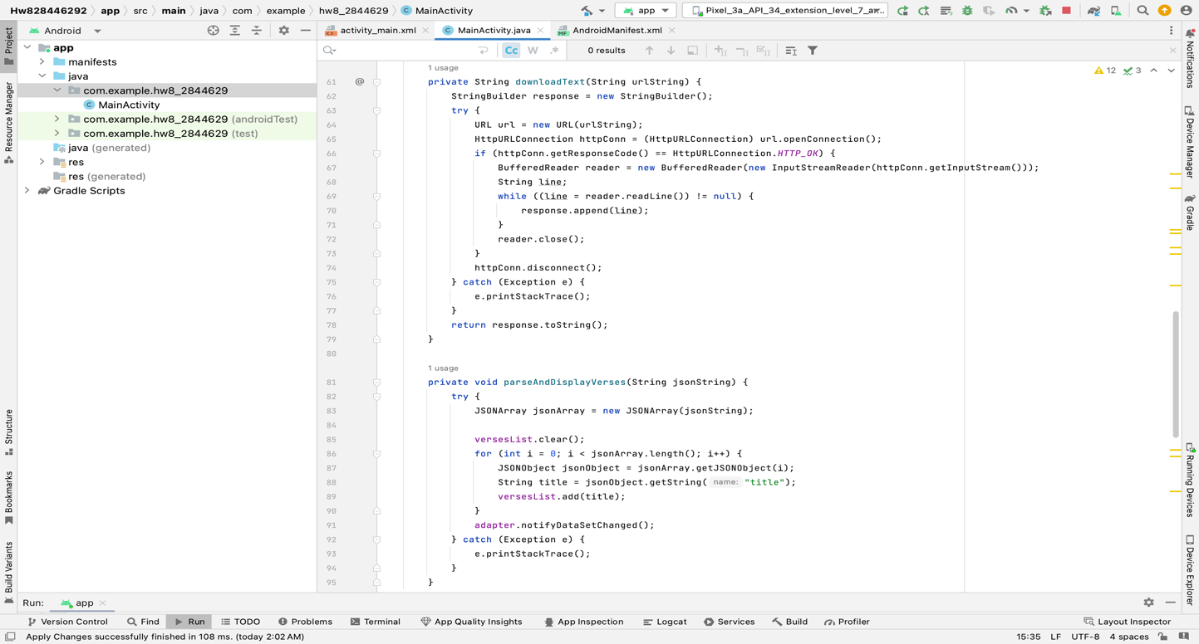
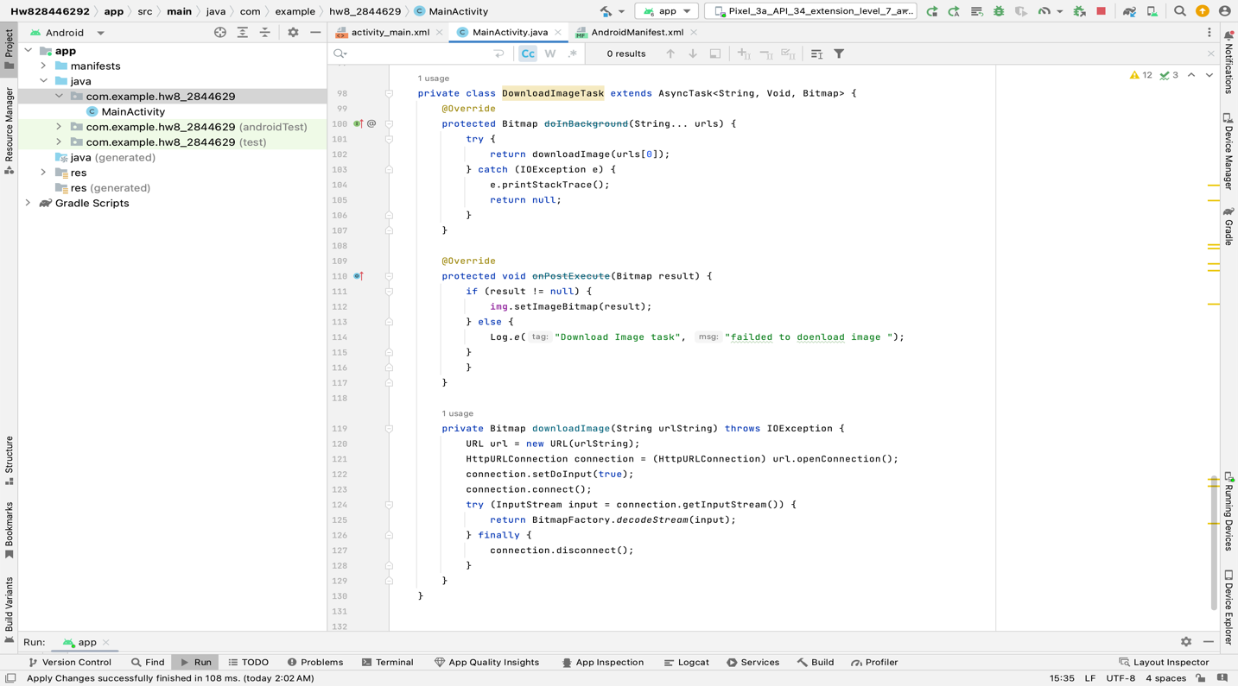

Main_activity.xml : A 'ListView' and a 'ImageView' are contained within a 'ConstraintLayout' in this XML layout. The 'ListView', which occupies the majority of the screen, displays a list of things, while the 'ImageView' at the bottom displays an image, both nicely organized in the app's main interface.

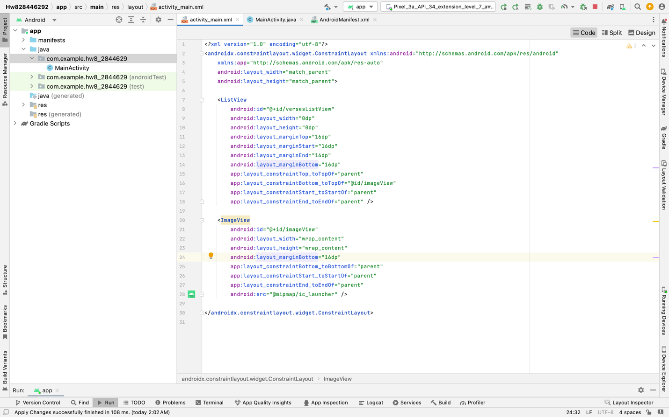
Android manifest : I added one additional thing in the android manifest “<uses-permission android:name="android.permission.INTERNET"/> as the app uses online resource to download the content like text and image

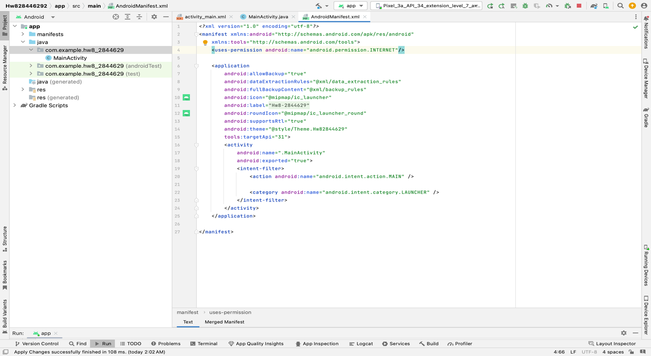

Below is the screenshot of the app running :

